The e-commerce platform ShopSmart uses Neo4j to track users, products, brands, categories, and reviews. Users view, buy, and rate products. Relationships include metadata like purchase dates, quantities, rating values, browsing duration, and similarity scores.
Entities (Nodes):
  - Users: 20 (Alice, Bob, Charlie, …)
  - Products: 50 (Product1, Product2, …)
  - Categories: 10 (Electronics, Books, Clothing, …)
  - Brands: 10 (BrandA, BrandB, …)
  - Reviews: 10 (Review1, Review2, …)
Relationships:
  - :BOUGHT {date, quantity, price_paid}, :VIEWED {date, duration_seconds, device}, :RATED {rating, review_date}, :REVIEWS {review_id}, :BELONGS_TO {added_date}, :MADE_BY {launch_year}, :SIMILAR_TO {similarity_score}, :FRIENDS_WITH {since, interaction_count}

CREATE Questions (with Properties)
- Create user nodes: Alice, Bob, Charlie with emails.
CREATE
(alice:User {name: "Alice", email: "alice@shopsmart.com"}),
(bob:User {name: "Bob", email: "bob@shopsmart.com"}),
(charlie:User {name: "Charlie", email: "charlie@shopsmart.com"});

- Create product nodes: Product1 (Electronics, 49.99), Product2 (Books, 29.99), Product3 (Clothing, 39.99).
CREATE
(p1:Product {name: "Product1", category: "Electronics", price: 49.99}),
(p2:Product {name: "Product2", category: "Books", price: 29.99}),
(p3:Product {name: "Product3", category: "Clothing", price: 39.99});

- Create category nodes: Electronics, Books, Clothing.
CREATE
(c1:Category {name: "Electronics"}),
(c2:Category {name: "Books"}),
(c3:Category {name: "Clothing"});

- Create brand nodes: BrandA, BrandB, BrandC.
CREATE
(bra:Brand {name: "BrandA"}),
(brb:Brand {name: "BrandB}),
(brc:Brand {name: "BrandC"});

- Create review nodes: Review1 (rating 5), Review2 (rating 4), Review3 (rating 3).
CREATE
(r1:Review{name: "Review1", ratings:5}),
(r2:Review {name: "Review2", rating: 4}),
(r3:Review {name: "Review3", rating: 3});

- Create BOUGHT relationship: Alice bought Product1 on 2025-10-14, quantity 2, price_paid 99.98.
MATCH (u:User {name: "Alice"})
MATCH (p:Product {name: "Product1"})
CREATE (u)-[:BOUGHT {date: date("2025-10-14"), quantity: 2, price_paid: 99.98}]->(p);

- Create BOUGHT relationship: Bob bought Product2 on 2025-10-13, quantity 1, price_paid 29.99.
MATCH(u:User{name:"Bob"})
MATCH(p:Product{name:"Product2"})
CREATE(u)-[:BOUGHT{date:date("2025-10-13"),quantity:1,price_paid:29.99}]->(p);

- Create VIEWED relationship: Charlie viewed Product3 on 2025-10-12 for 120 seconds on mobile.
MATCH (u:User {name: "Charlie"})
MATCH(p:Product {name: "Product3"})
CREATE (u)-[:VIEWED {date: date("2025-10-12"), duration_seconds: 120, device: "mobile"}]->(p);

- Create BELONGS_TO relationship: Product1 belongs to Electronics, added_date 2025-01-01.
MATCH(p:Product {name: "Product1"})
MATCH(c:Category {name: "Electronics"})
CREATE (p)-[:BELONGS_TO {added_date: date("2025-01-01")}]->(c);

- Create MADE_BY relationship: Product1 made by BrandA, launch_year 2024.
MATCH (p:Product {name: "Product1"})
Match(b:Brand {name: "BrandA"})
CREATE (p)-[:MADE_BY {launch_year: 2024}]->(b);

- Create RATED relationship: Alice rated Review1 on 2025-10-14; Review1 reviews Product1.
MATCH (u:User {name: "Alice"})
MATCH(r:Review {name: "Review1"})
MATCH(p:Product {name: "Product1"})
CREATE (u)-[:RATED {rating: 5, review_date: date("2025-10-14")}]->(r),(r)-[:REVIEWS]->(p);

- Create SIMILAR_TO relationship: Product1 is similar to Product3, similarity_score 0.85.
MATCH (p1:Product {name: "Product1"})
MATCH(p3:Product {name: "Product3"})
CREATE (p1)-[:SIMILAR_TO {similarity_score: 0.85}]->(p3);

- Create FRIENDS_WITH relationship: Alice friends with Bob since 2023-01-01, interaction_count 15.
MATCH (a:User {name: "Alice"})
MATCH(b:User {name: "Bob"})
CREATE (a)-[:FRIENDS_WITH {since: date("2023-01-01"), interaction_count: 15}]->(b);

- Create BOUGHT relationship: Charlie bought Product2 on 2025-10-14, quantity 1, price_paid 29.99.
MATCH (u:User {name: "Charlie"})
MATCH(p:Product {name: "Product2"})
CREATE (u)-[:BOUGHT {date: date("2025-10-14"), quantity: 1, price_paid: 29.99}]->(p);

- Create VIEWED relationship: Alice viewed Product2 on 2025-10-13 for 45 seconds on desktop.
MATCH (u:User {name: "Alice"})
MATCH(p:Product {name: "Product2"})
CREATE (u)-[:VIEWED {date: date("2025-10-13"), duration_seconds: 45, device: "desktop"}]->(p);

QUERY Questions (with Properties)
- Find all products purchased by Alice, including quantity and date.
MATCH (a:User {name: 'Alice'})-[b:BOUGHT]->(p:Product)
RETURN p.name AS Product, b.quantity AS Quantity, b.date AS PurchaseDate;
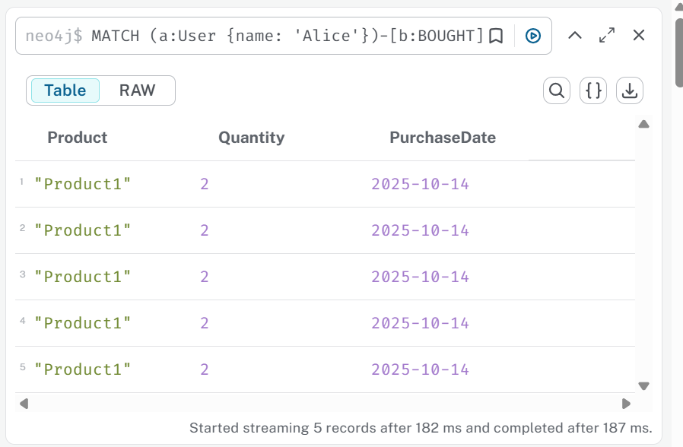
- Recommend products for Alice based on products Bob bought in the last month.
MATCH (a:User {name: 'Alice'}), (b:User {name: 'Bob'})-[:BOUGHT]->(p:Product)
WHERE b<>a AND b.date >= date() - duration('P30D')
RETURN DISTINCT p.name AS RecommendedProducts;
O/P: No changes .
- List all products in the Electronics category and show when they were added.
MATCH (p:Product)-[r:BELONGS_TO]->(c:Category {name: 'Electronics'})
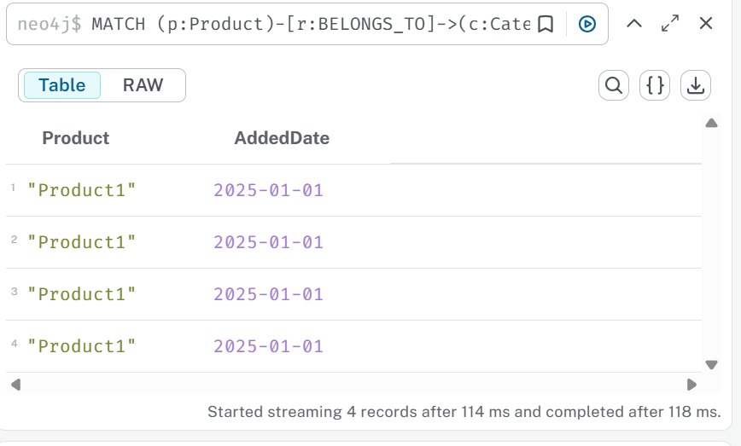
RETURN p.name AS Product, r.added_date AS AddedDate;

- Find top 5 products by average rating, including the latest review date.
MATCH (u:User)-[r:RATED]->(rev:Review)-[:REVIEWS]->(p:Product)
RETURN p.name AS Product,
AVG(r.rating) AS AvgRating,
MAX(r.review_date) AS LatestReview
ORDER BY AvgRating DESC
LIMIT 5;
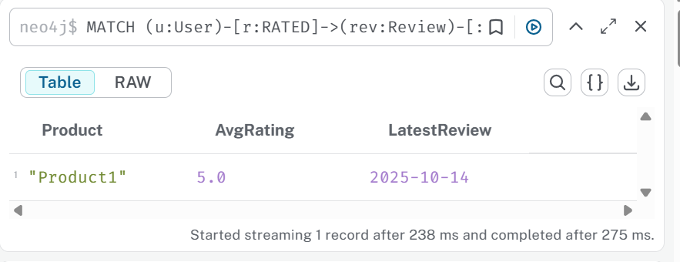
- Find all products made by BrandB and launch year.
MATCH (p:Product)-[m:MADE_BY]->(b:Brand {name: 'BrandB'})
RETURN p.name AS Product, m.launch_year AS LaunchYear;
O/P: No changes
- Find users who viewed Product3 but did not buy it; show viewing duration and device.
MATCH (u:User)-[v:VIEWED]->(p:Product {name: 'Product3'})
WHERE NOT (u)-[:BOUGHT]->(p)
RETURN u.name AS User, v.duration_seconds AS Duration, v.device AS Device;
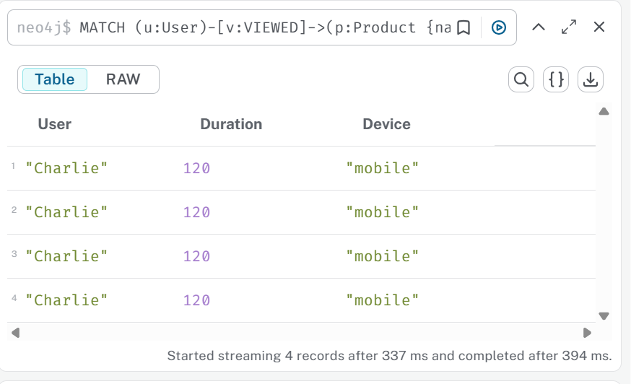
- Find the category with the highest total purchased quantity.
MATCH (u:User)-[b:BOUGHT]->(p:Product)-[:BELONGS_TO]->(c:Category)
RETURN c.name AS Category, SUM(b.quantity) AS TotalQuantity
ORDER BY TotalQuantity DESC
LIMIT 1;
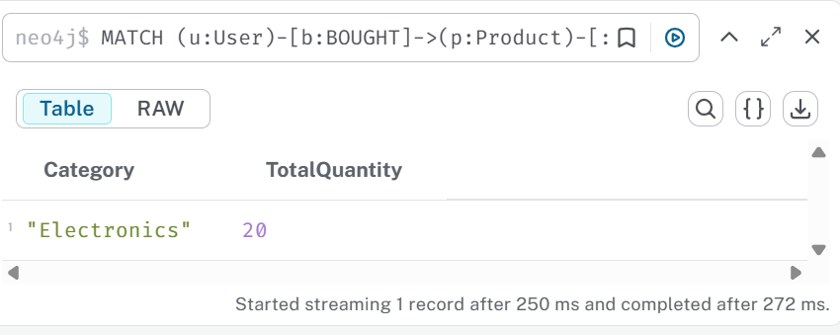
- Find all users who rated Product1 with 5 stars, including review date.
MATCH (u:User)-[r:RATED {rating: 5}]->(rev:Review)-[:REVIEWS]->(p:Product {name: 'Product1'})
RETURN u.name AS User, r.review_date AS ReviewDate;
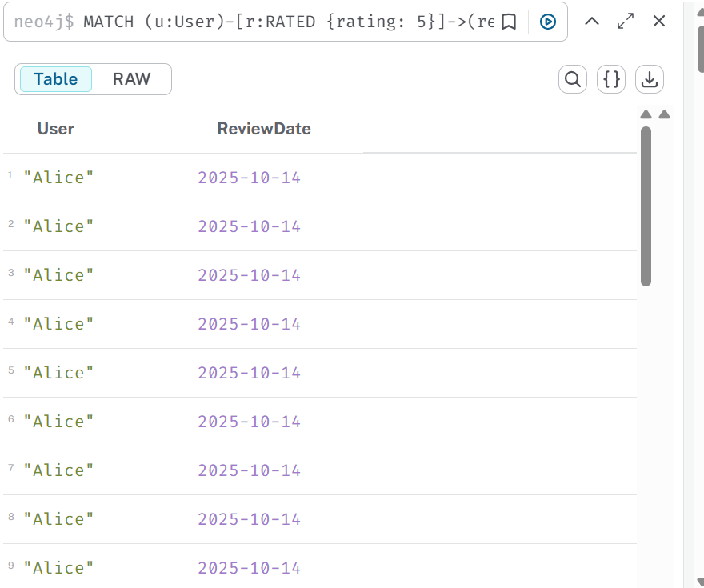
- Suggest products similar to Product1 with similarity_score > 0.8.
MATCH (p1:Product {name: 'Product1'})-[s:SIMILAR_TO]->(p2:Product)
WHERE s.similarity_score > 0.8
RETURN p2.name AS SimilarProduct, s.similarity_score AS SimilarityScore;
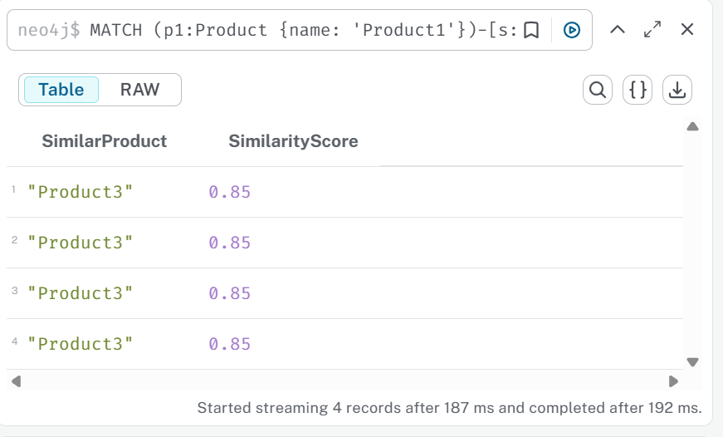
- Find friends of Alice who purchased Product2, showing purchase date.
MATCH (a:User {name: 'Alice'})-[:FRIENDS_WITH]->(f:User)-[b:BOUGHT]->(p:Product {name: 'Product2'})
RETURN f.name AS Friend, b.date AS PurchaseDate;
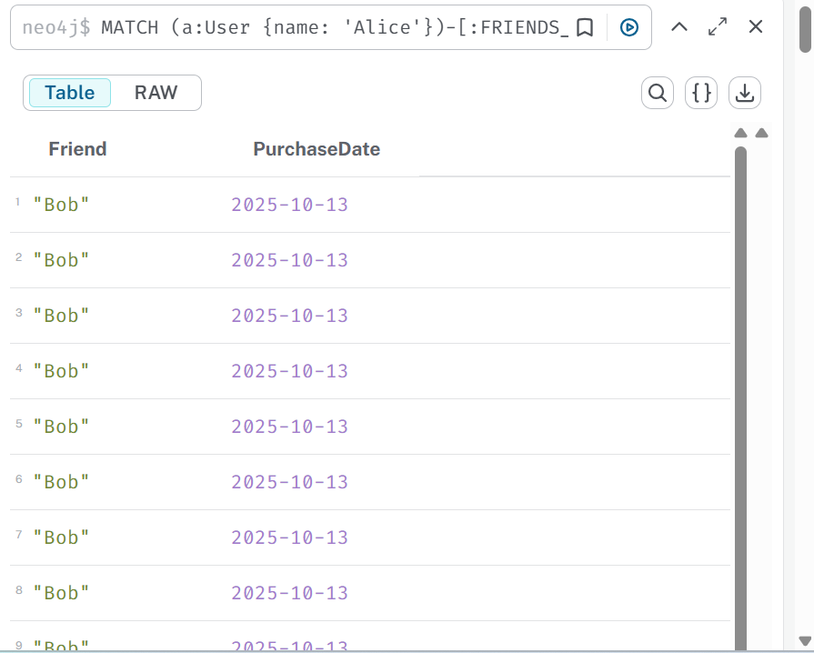
- List all reviews for Product2 along with user and rating.
MATCH (u:User)-[r:RATED]->(rev:Review)-[:REVIEWS]->(p:Product {name: 'Product2'})
RETURN u.name AS User, rev.name AS Review, r.rating AS Rating;
O/P: No changes .
- Find users who bought products from multiple categories, showing product names and categories.
MATCH (u:User)-[:BOUGHT]->(p:Product)-[:BELONGS_TO]->(c:Category)
WITH u, COLLECT(DISTINCT c.name) AS Categories, COLLECT(DISTINCT p.name) AS Products
WHERE SIZE(Categories) > 1
RETURN u.name AS User, Products, Categories;
O/P: No Changes.
- Find products viewed more than 100 seconds by any user.
MATCH (u:User)-[v:VIEWED]->(p:Product)
WHERE v.duration_seconds > 100
RETURN DISTINCT p.name AS Product, v.duration_seconds AS Duration, u.name AS ViewedBy;
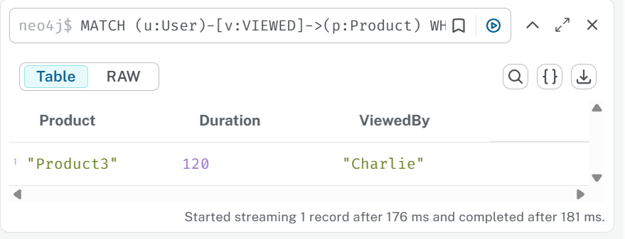
- Recommend products based on friends’ purchases in the last 30 days.
MATCH (a:User {name: 'Alice'})-[:FRIENDS_WITH]->(f:User)-[b:BOUGHT]->(p:Product)
WHERE b.date >= date() - duration('P30D')
RETURN DISTINCT p.name AS RecommendedProduct, f.name AS Friend;
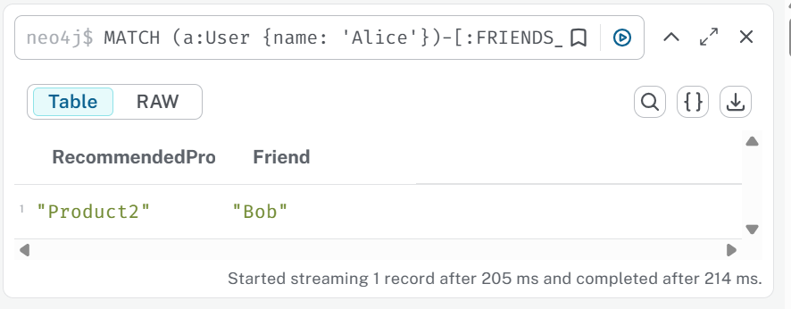
- Find products frequently bought together with Product2, including purchase dates.
MATCH (u:User)-[b1:BOUGHT]->(p1:Product {name: 'Product2'}),
(u)-[b2:BOUGHT]->(p2:Product)
WHERE p1 <> p2
RETURN p2.name AS BoughtTogether, COLLECT(b2.date) AS PurchaseDates;
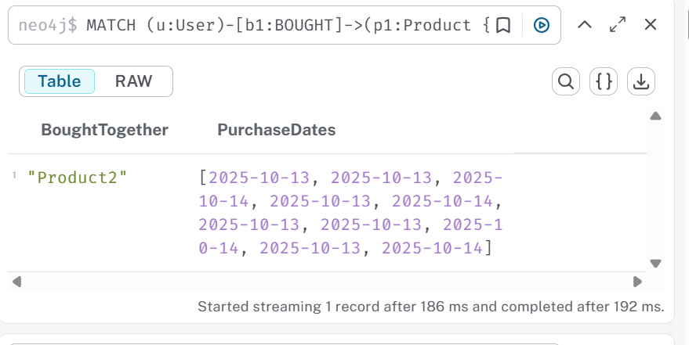

UPDATE Questions (with Properties)
- Update the price of Product1 to 99.99.
MATCH (p:Product {name: "Product1"})
SET p.price = 99.99
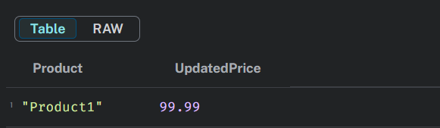
RETURN p.name AS Product, p.price AS UpdatedPrice;

- Add Product1 to a new category “Gadgets” with added_date 2025-10-14.
MERGE (c:Category {name: "Gadgets"}) WITH c
MATCH (p:Product {name: "Product1"})
MERGE (p)-[r:BELONGS_TO]->(c)
SET r.added_date = date("2025-10-14")
RETURN p.name AS Product, c.name AS Category, r.added_date AS AddedDate;
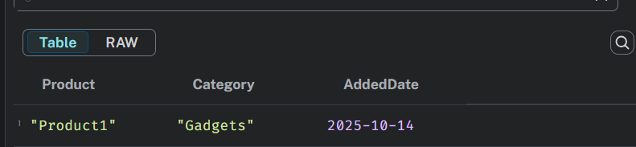
- Update Alice’s email to alice_new@example.com.
MATCH (u:User {name: "Alice"})
SET u.email = "alice_new@example.com"
RETURN u.name AS User, u.email AS UpdatedEmail;
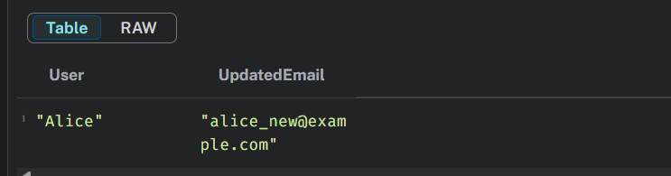
- Update Review1 rating to 4 on 2025-10-15.
MATCH (r:Review {name: "Review1"})
SET r.rating = 4, r.last_updated = date("2025-10-15")
RETURN r.name AS Review, r.rating AS UpdatedRating, r.last_updated AS UpdatedDate;
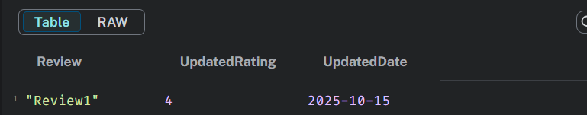
- Add a BOUGHT relationship: Charlie bought Product3 on 2025-10-14, quantity 1, price_paid 39.99.
MATCH (u:User {name: "Charlie"}), (p:Product {name: "Product3"})
MERGE (u)-[b:BOUGHT {date: date("2025-10-14")}]->(p)
SET b.quantity = 1, b.price_paid = 39.99
RETURN u.name AS User, p.name AS Product, b.date AS PurchaseDate, b.price_paid AS Price;
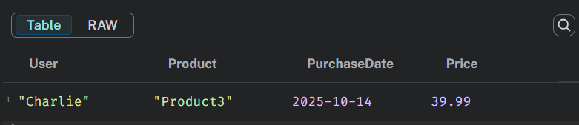
- Change the brand of Product3 from BrandC to BrandD, launch_year 2025.
MATCH (p:Product {name: "Product3"})-[old:MADE_BY]->(b1:Brand {name: "BrandC"})
DELETE old
MERGE (b2:Brand {name: "BrandD"})
MERGE (p)-[new:MADE_BY]->(b2)
SET new.launch_year = 2025
RETURN p.name AS Product, b2.name AS NewBrand, new.launch_year AS LaunchYear;
O/p: No changes, no records
- Rename Product2 to “BookMaster 2025”.
MATCH (p:Product {name: "Product2"})
SET p.name = "BookMaster 2025"
RETURN p.name AS NewProductName;
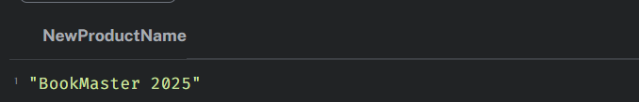
- Update the names of users Bob and Charlie to Robert and Charles.
MATCH (u:User)
WHERE u.name IN ["Bob", "Charlie"]
SET u.name = CASE u.name
WHEN "Bob" THEN "Robert"
WHEN "Charlie" THEN "Charles"
END
RETURN u.name AS UpdatedNames;
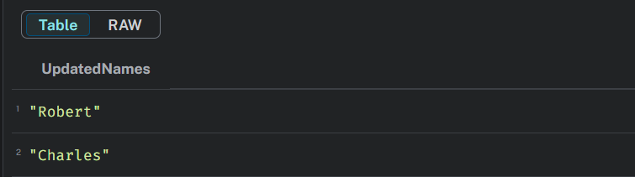
- Change category of Product3 from Clothing to Sports, added_date 2025-10-14.
MATCH (p:Product {name: "Product3"})-[old:BELONGS_TO]->(c1:Category {name: "Clothing"})
DELETE old
MERGE (c2:Category {name: "Sports"})
MERGE (p)-[new:BELONGS_TO]->(c2)
SET new.added_date = date("2025-10-14")
RETURN p.name AS Product, c2.name AS NewCategory, new.added_date AS AddedDate;
O/p: No changes needed
- Add a new attribute discount = 10% to Product1.
MATCH (p:Product {name: "Product1"})
SET p.discount = "10%"
RETURN p.name AS Product, p.discount AS Discount;
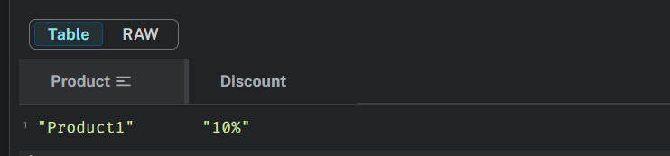

DELETE Questions (with Properties)
- Delete Product50 from the database.
MATCH (p:Product {name: "Product50"})
DETACH DELETE p;

- Delete Review5 with rating 2.
MATCH (r:Review {name: "Review5",rating:2})
DETACH DELETE r;
O/P: No changes
- Remove BOUGHT relationship between Alice and Product2.
MATCH (a:User {name: "Alice"})-[r:BOUGHT]->(p:Product {name: "Product2"})
DELETE r;
O/P: No changes

- Delete category “OldCategory” and all associated relationships.
MATCH (c:Category {name: "OldCategory"})
DETACH DELETE c;
O/P: No changes
- Delete user Tina and all relationships.
MATCH (u:User {name: "Tina"})
DETACH DELETE u;
O/P: No changes
- Remove SIMILAR_TO relationship between Product1 and Product3.
MATCH (p1:Product {name: "Product1"})-[r:SIMILAR_TO]->(p3:Product {name: "Product3"})
DELETE r;
O/P: deleted 1 relationship
- Delete all products made by BrandJ.
MATCH (b:Brand {name: "BrandJ"})<-[:MADE_BY]-(p:Product)
DETACH DELETE p;
O/P:no changes
- Delete all VIEWED relationships for Product3 before 2025-01-01.
MATCH (u:User)-[v:VIEWED]->(p:Product {name: "Product3"})
WHERE v.date < date("2025-01-01")
DELETE v;
O/P: No changes
- Delete products never bought or reviewed (Product48, Product49).
MATCH (p:Product)
WHERE p.name IN ["Product48", "Product49"]
AND NOT ( ()-[:BOUGHT]->(p) OR ()-[:REVIEWS]->(p) )
DETACH DELETE p;
O/P: no changes
- Delete Review3 without deleting Product3.
MATCH (r:Review {name: "Review3"})
DETACH DELETE r;
O/P: Delete 1 node

ANALYTICAL / COMPLEX Query Questions (with Properties)
- Find top 5 users by purchase quantity in October 2025.
MATCH(u:User)-[b:BOUGHT]->(p:Product)
WHERE b.date>=date("2025-10-01") AND b.date <=date("2025-10-31")
RETURN u.name AS User ,SUM(b.quantity) AS TotalQuantity ORDER BY TotalQuantity Limit 5;
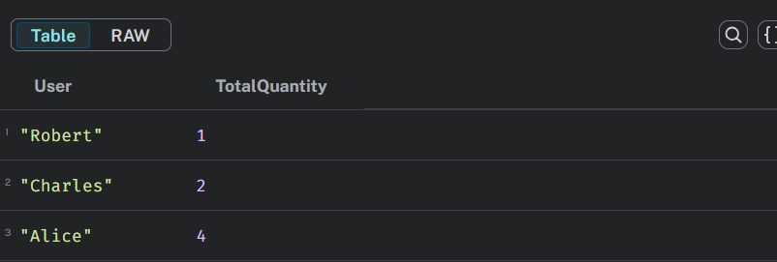
- Recommend products for Alice based on purchases in Electronics category.
MATCH (alice:User {name: "Alice"})-[:BOUGHT]->(p1:Product)-[:BELONGS_TO]->(c:Category {name: "Electronics"})
MATCH (other:User)-[:BOUGHT]->(p2:Product)-[:BELONGS_TO]->(c)
WHERE other <> alice AND NOT (alice)-[:BOUGHT]->(p2)
RETURN DISTINCT p2.name AS RecommendedProduct, c.name AS Category
LIMIT 10;
O/P: No changes
- Identify products frequently bought together with Product2 in the last 30 days.
MATCH (u:User)-[b1:BOUGHT]->(p1:Product {name: "Product2"})
MATCH (u)-[b2:BOUGHT]->(p2:Product)
WHERE p1 <> p2 AND b1.date >= date() - duration('P30D')
RETURN p2.name AS CoBoughtProduct, COUNT(*) AS Frequency
ORDER BY Frequency DESC
LIMIT 5;

- Find average rating for products made by BrandA.
MATCH (b:Brand {name: "BrandA"})<-[:MADE_BY]-(p:Product)<-[:REVIEWS]-(r:Review)
RETURN b.name AS Brand, AVG(r.rating) AS AvgRating;
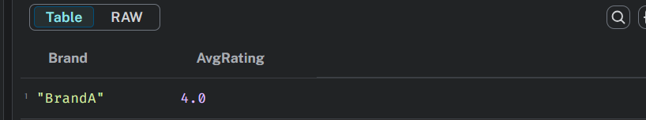
- Suggest products for Alice based on her friends’ purchases, including purchase dates.
MATCH (a:User {name: "Alice"})-[:FRIENDS_WITH]-(f:User)-[b:BOUGHT]->(p:Product)
WHERE NOT (a)-[:BOUGHT]->(p)
RETURN DISTINCT p.name AS SuggestedProduct, f.name AS Friend, b.date AS PurchaseDate
ORDER BY b.date DESC;
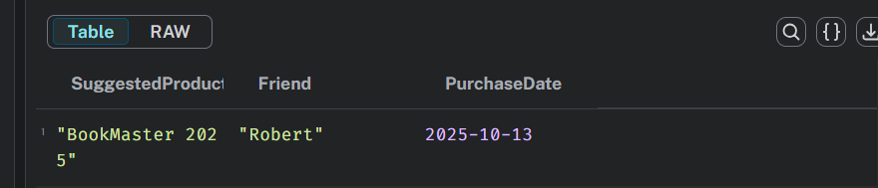
- Find users who bought products with price_paid > 80.
MATCH (u:User)-[b:BOUGHT]->(p:Product)
WHERE b.price_paid > 80
RETURN DISTINCT u.name AS User, p.name AS Product, b.price_paid AS PricePaid
ORDER BY b.price_paid DESC;
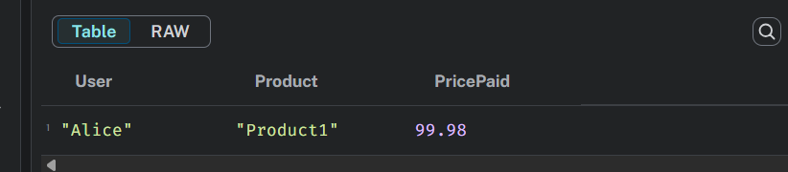
- Identify categories generating the highest total revenue (sum of price_paid × quantity).
MATCH (u:User)-[b:BOUGHT]->(p:Product)-[:BELONGS_TO]->(c:Category)
RETURN c.name AS Category, ROUND(SUM(b.price_paid)) AS TotalRevenue
ORDER BY TotalRevenue DESC
LIMIT 5;
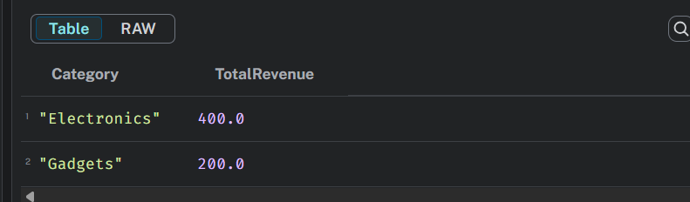
- Find products viewed >100 seconds but never bought.
MATCH (u:User)-[v:VIEWED]->(p:Product)
WHERE v.duration_seconds > 100
AND NOT (u)-[:BOUGHT]->(p)
RETURN DISTINCT p.name AS Product, v.duration_seconds AS Duration
ORDER BY Duration DESC;
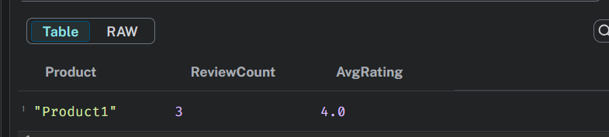
- List products with review count and average rating.
MATCH (p:Product)<-[:REVIEWS]-(r:Review)
RETURN p.name AS Product, COUNT(r) AS ReviewCount, ROUND(AVG(r.rating),2) AS AvgRating
ORDER BY AvgRating DESC, ReviewCount DESC;
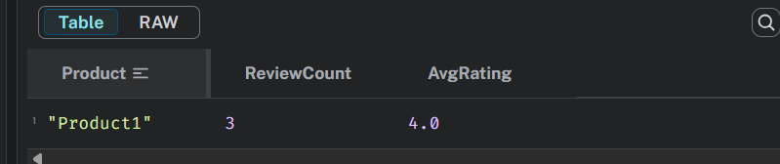

- Identify potential bundles of Product1, Product2, Product3 based on co-purchases.
MATCH (u:User)-[:BOUGHT]->(p:Product)
WHERE p.name IN ["Product1", "Product2", "Product3"]
WITH u, COLLECT(p.name) AS PurchasedProducts
WHERE SIZE(PurchasedProducts) > 1
RETURN PurchasedProducts AS Bundle, COUNT(*) AS Frequency
ORDER BY Frequency DESC;
